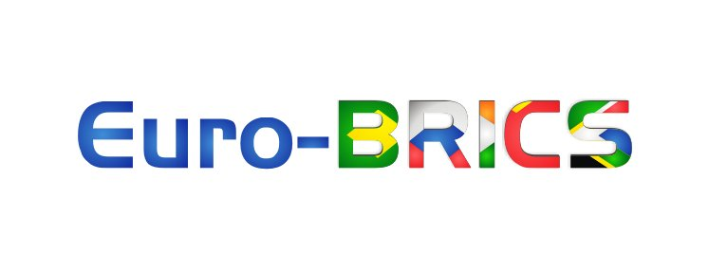

Euro-BRICS Process

5th Euro-BRICS conference

« Regional integrations as a model for XXIst century multipolar global governance »

Helsinki, June 8, 2015

Work document

Rationale

The Ukrainian crisis which marked the year 2014 was analysed by LEAP’s Euro-BRICS network as the result of an overlap between two economic unions, the European Union and the Eurasian Economic Union, having failed to cooperate in creating the conditions for a non-conflictual co-development. In other words : « the first conflict of the multipolar world ». Indeed the multipolarity of the XXIst century world is neither good or bad, it is a fact which policy-makers must address with optimism and rationality in order to organise it so that today’s multipolar world doesn’t look like Europe in the 1930s.

More generally, the Euro-Russian crisis, as well as all those currently multiplying in the Middle-East and worldwide, clearly signal that the system of global governance is breathless and that it is now a matter of emergency to reform, see rebuild, it in order to avoid – or at least limit in duration – a loss of control of the geopolitical situation.

Since 2009, LEAP has been anticipating that a rapprochement between Europe and the BRICS was likely to contribute significantly to reinventing tomorrow’s global governance:
. the euro-BRICS axis is representative of today’s global balance in terms of economic and demographic weight namely
. the BRICS countries are emblematic of the emerging multipolar world
. Europe must acknowledge this reality to prevent a West/BRICS bipolarisation

Lastly, Europe and the BRICS anchor themselves into experiences of regional integration which provide a natural model for mutipolar global governance. European Union, Mercosur, African Union, Eurasian Union,… are indeed successful processes of integration of nation-states of different size and culture.

These regional integrations probably account for the most successful achievement of nation-states in the second half of the XXth century. But today these nation-states seem to hesitate to finalise this process of organisation of the XXIst century world, a hesitation likely to nullify all the work done until now.

Supra-national entities are indeed faced to three challenges today:
. achieve their democratic anchorage in order to gain the political legitimacy they need (and deserve) to operate normally (Towards a political validation of regional entities)
. find their place in a global architecture today suffering from relying on the national level only (Towards the creation of the intermediate level of global architecture)
. adapt their model of inter-state cooperation to inter-block cooperation on a global level (Towards a multipolar global governance).

The 5th Euro-BRICS conference intends to tackle this issue of the integration of supra-national (EU, AU, Eurasia, Mercosur…) and mega-national (China, India…) entities to the global architecture, as well as its feasibility and the role states must play in this finalisation of the process of regional integration and establishing of a multipolar global governance adapted to the characteristics of the XXIst century.

Format/themes of the conference

This conference will take place in Helsinki, 40 years exactly after the Helsinki Declaration was signed in an attempt to improve relations between the Communist bloc and the West.

LEAP and the Euro-BRICS network wish to gather around 50 representatives of national Ministries of Foreign Affairs (Brazil, Russia, India, China, South Africa and European countries) and supra-national entities (EU, AU, Eurasia, Mercosur, etc…) for one day of discussions on the four following themes:

. Taking on the political dimension of the process of regional integration
. Integrating regional blocs to the global governance: states – regions - world
. Adapting the model of regional integration to the construction of a multipolar global governance
. Obstacles, feasibility and role of states in the process

Each of these four themes will be addressed along the lines of four concrete fields of urgent global coordination:
- Defence and security
- Currency
- Energy and commodities
- Trade

Goals

The findings of the presentations and discussions that will result from each of these topics will provide the input for strategic recommendations to be forwarded to G20, BRICS and European decision makers and representatives.

A combination of two meetings

This meeting is combined with a second important event, a « Euro-BRICS young leaders Meeting », gathering 100 representatives of student and youth organisations from Europe and the BRICS on the idea of « Young leaders and citizens from Europe and the BRICS welcome the multipolar world ».

Indeed this XXIst century world belongs first and foremost to the younger generations of global citizens and leaders, these generations don’t want to see the older generations ruin their hopes of a peaceful and prosperous multipolar world. The world needs the optimism and open-mindedness of the owners of the future to go forward and project positively in the future.

PROGRAMME

Moderation: Marie-Hélène Caillol and Veronique Swinkels

Sunday, June 7, 2015 – Arrival of participants

20.00 Welcome drink

Monday, June 8, 2015

(diplomatic event held in parallel to Euro-BRICS Young leaders’ workshops)

09.00 – 9.30 Introductions and round-table

9.30 – 11.00 Taking on the political dimension of the process of regional integration

11.00 – 11.30 Break

11.30 – 13.00 Integrating regional blocs to the global governance: states – regions - world

13.00 – 14.00 Lunch

14.00 – 15.30 Adapting the model of regional integration to the construction of a multipolar global governance

15.30 – 16.00 Break

16.00 – 17.30 Obstacles, feasibility and role of states in the process

17.30 – 18.00 Conclusions and closing

18.30 Dinner

Tuesday, June 9, 2015 – Plenary and departures

(reporting of official meeting’s conclusion in the Euro-BRICS Young Leaders Meeting in the presence of political keynote speakers)

Lire conclusions du séminaire en ligne Euro-BRICS du 29 septembre 2014. Source : LEAP/Euro-BRICS, 03/12/2014

